**Dr. Vivek Varma**

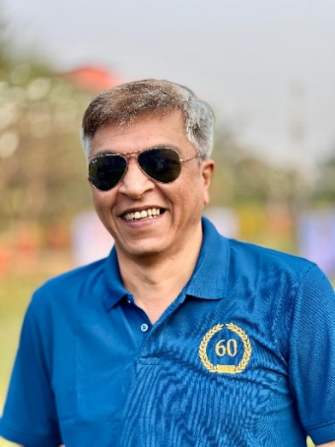Founder Director - LabCare Diagnostics

Founder Director - Stellium Inc

Ex-Technical Director – Premier Medical Corporation

Dr. Vivek Varma has been part of the Life Science Industry since 1992, when he completed his Ph.D in Biotechnology. Armed with an additional qualification in MDBA in Marketing, he entered the field of Marketing and Sales of Life Science products.

He has more than 30 years of experience in Marketing & Sales, Operations, Production and Regulatory Affairs in the Life Science and Medical Device Industry.

He was also involved in creating Business plans for the emerging CRO based companies in India. He ventured into the field of Diagnostics and founded a Diagnostic company, providing Diagnostic reagents. After a successful establishment of the company, he assisted various diagnostic companies in streamlining their Manufacturing and regulatory processes for addressing the Global market. He was instrumental in introducing many innovative products in the Indian market like the BET and also helped in including the same in the Indian Pharmacopoeia.

His passion for learning moved him to establish a Logistics based IT Consulting firm in India and US. With his interest in being in the forefront of Technology, he was involved in the Business Development of AI- Based products.

Presently, he is involved in assisting Startups with their Business Strategies as a Mentor or Life Science Consultant. His latest passion is being an Agripreneur.